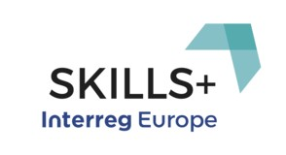

SKILLS + BASELINE STUDY
By UNIVERSITY OF WESTERN MACEDONIA
Greece

V10

Table of Contents
Table of Contents 2
1. Territorial Characteristics (general geographical data, general business data, broadband coverage, policy context) 4
1.1 General geographical data 4
1.2 Population composition 5
1.3 General business and economic indicators 5
1.4 The key features of the Region per sector of economic activity 10
1.5 Employment 11
1.6 Unemployment in RWM 12
1.7 The Region of Western Macedonia and Europe 2020 strategy 12
1.8 Summary 13
2. The Digital Economy in Greece 13
2.1 Greece’s Digital Economy Profile 16
2.2 Integration of Digital Technology in Greece 18
2.3 Characteristics of ICT in Western Macedonia Region 22
3. Main Stakeholders of CCI of Western Macedonia Region 28
4. Regional Policy: drawbacks and Initiatives for digitalization of SMEs 29
4.1 Barriers to efficient implementation of Digital Actions in Greece 30
4.2 The challenges that the Western Macedonia businesses face 32
4.3 Support available to businesses wishing to upscale the use of digital tools 35
4.4 Main driving forces in the digitalization of rural SME’s business activities 36
5. SWOT analysis 37
6. Analysis and identification of main regional experience and lessons learnt/ Good practice assessment 38
6.1 Selection of good practices from other SKILLS+ partner regions 42
7. Conclusions 46
8. List of bibliography 49
9. List of stakeholders interviewed – Questionnaires 50
List of stakeholders: 50
A: Three (3) SMEs in the regions of Nestorio and One (1) SME in Grevena 50
B: One (1) Telecommunications Provider – Forthnet Kozani 50
A. Questions addressed to SMEs in Western Macedonia: 50
Stakeholder Information 50
Questionnaire 50
Stakeholder Information 53
Questionnaire 53

Territorial Characteristics (general geographical data, general business data, broadband coverage, policy context)
This section includes general geographical and business data for the region of Western Macedonia.

General geographical data
The Region of Western Macedonia (RWM) has a total area of 9.451 km2 (7,16% of the country) and is the gateway of Greece and the European Union to the Western Balkans, bordering at the northwest side of the country with Albania and FYROM. RWM consists of the Regional Units (RU) of Kozani, Grevena, Kastoria and Florina.
The geographical position of Western Macedonia, combined with the fact that is the only region of Greece without sea, form a spatial unity with special physical characteristics that include both mountainous and semi-mountainous areas (82%), a diverse natural environment with rich fauna and flora and the largest surface of water resources in the country. These features create an area that can become an attractive place for the development of productive activities and living by applying the appropriate developmental model.
At Regional Unit level, the RU of Kozani, on the eastern side of WMAR, is the largest in size (3,516 km2), and is covered mainly by mountainous and semi- mountainous land (77%). The RU of Grevena, covering a total of 2,291 km2, is the most mountainous region in WMAR (93% of its land is considered mountainous and semi-mountainous), while the Florina RU is the third largest (1,925 km2) and has the highest share of lowlands (26%). The smallest region of RWM, the RU of Kastoria (1,720 km2), is covered almost entirely by mountainous and semi-mountainous areas (90%).
RWM is well known for its rich natural resources, such as fossil fuels (lignite), ores (asbestos, chromite, marble etc.), forests (50% of its total land) that form ecosystems defined by rich biodiversity, as well as pastures, while it also has the greatest surface water potential in Greece (approximately 65% of the country).
Τhe completion of the European trans-national road network reinforces both the internal cohesion of the region, and the establishment of a single Balkan cooperation and development area. Consequently, Western Macedonia is transformed from a border region that was previously detached by its neighbors, into an area of strategic importance that is constantly strengthening its position in terms of communication, energy and cross border business opportunities.

Population composition

The population of RWM has been significantly reduced over the past 50 years, as, according to the official census, it has dropped by 9.7% between 1961-2011. According to the latest Eurostat figures, the population of the area was estimated at 278,706 in 2014, i.e. there is an additional 1.8% drop between 2011 and 2014. The most significant population reduction trend is noted in the RU of Grevena (27% between 1961 and 2011) - which also has the highest ageing rates - followed by the RU of Florina (23.7%) and Kozani (1.7%), which is the most populated, too. The RU of Kastoria is the only one where the population shows an increasing trend (6%).

The population density in 2013 was 42.8 people/km2 in the RU of Kozani, 29.2 people/km2 in the RU of Kastoria, 28.1 people/km2 in the RU of Florina and 13.7 people/km2 in the RU of Grevena, making the latter the least populated Regional Unit in the whole of Greece.

General business and economic indicators
The energy sector plays a dominant role in the regional economy of Western Macedonia. It highly contributes to the total energy production at the national level (the thermal and hydropower plants of the region participated from 52% to 55% in total electricity production in the period 2010-12), making the Western Macedonia the energy center of the country.
As part of the 4th Programming Period, Western Macedonia was one of the three Statistical Convergence regions (Phasing Out) of Greece with the per capita Gross Domestic Product in Purchasing Power Standards (PPS) higher than 75% of the corresponding EU-25 and less than 75% of the EU-15, taking into consideration 2003 as base year.
In the new programming period, Western Macedonia is part of the Transitional Support Regions since the GDP per capita for the period 2007 - 2009 is 85.6% of the corresponding EU-27.
Although, the above classification does not reflect the current situation of Western Macedonia as the unprecedented economic crisis that affects the country, since 2008, has led to a significant recession of the Greek economy, which has affected negatively the GDP per capita (in PPS) of Western Macedonia forming it to a lower ratio than the corresponding one according to the EU-27 level, namely 80% of the corresponding average (Table 1).

Table 1.1 GDP per capita in PPS (Purchasing Power Standards) at national, regional (Western Macedonia Region) and European (EU-27) level, 2008-2010.

 | Western Macedonia |  | Greece |  | EU-27
 | PPS | % ON THE ΕU- 27AVERA GE | PPS | % ON THE ΕU- 27AVERA GE | PPS | % ON THE ΕU- 27AVERA GE
2008 | 21,300 | 85 | 23,100 | 92 | 25,100 | 100
2009 | 20,100 | 86 | 22,100 | 94 | 23,500 | 100
2010 | 19,600 | 80 | 21,200 | 87 | 24,500 | 100
Source: Eurostat 9/2013
The consequences of the crisis are much more apparent in employment rates. In Western Macedonia (for ages over 15 years old), according to Eurostat data for 2012 unemployment has reached 29.9% versus 24.1 % across the country and 10.2% of total EU-27 countries, while according to ELSTAT for the second quarter of 2013 the unemployment rate in Western Macedonia has reached 32.9%.
The above percentages proves that the integration of Western Macedonia in the "phasing out" regions, through the one-dimensional approach that interprets the level of prosperity of a region exclusively by the produced per capita GDP, proved due to the crisis, that it did not correspond to the full regional development reality, since the existing structural weaknesses in the economy contributed in making the situation worse.
The region of Western Macedonia contributes by 2.4 % to the national Gross Value Added (GVA). The Regional GVA contributes to the national GVA by sector as follows: 4% from the agriculture sector, 7.5% from the Industry and Construction sector (including mining and energy) and 1% from the services sector (ELSTAT, 2014). The GDP per capita for 2014 was 15.624 Euros which is 9.5 % below the national average and 0.5% below the GDP per capita for 2013. The region’s Disposable income is 2.767 Euros. Regarding the sectoral composition of employment in the region, 19.5% of the working population is employed in the primary sector, 26.8% in the secondary sector and 34.4% in the tertiary sector (ELSTAT 2014).
According to Hellenic Statistical Authority, RWM's Total Gross Value Added in 2014 is estimated at €3.831 million Euros (current rates), and its distribution per sector is presented in Figure 1.1. Similarly, Figure 1.2 shows the gross added value per production sector, with the mining, industry, power production etc. sector contributing the largest share, €1.8 million at current rates (2014). The energy production sector (electricity production through lignite combustion and hydroelectric energy) is the main economic activity of the regional
economy, rendering Western Macedonia Greece's as the "energy center" of the country.

Figure 1.1: Contribution of each sector to the GDP of RWM in 2014 (ELSTAT)

Figure 1.2: Gross added value per production sector in RWM in 2014 (current rates, € million) (ELSTAT)

Table 1.2 presents the GDP per capita (at current market prices) at the four regional units of Western Macedonia and the percentage of the GDP of the national and EU 28 average. The Regional Unit of Kozani and Florina present a better situation in terms of GDP per capita mainly due to the mining and electricity production industry. The Regional Units of Kastoria and Grevena present similar images according to the demographic indicators.

Table 1.2. GDP per capita at current market prices

 | R.U. of Grevena | R.U. of Kastoria | R.U. of Kozani | R.U. of Florina
Population (2011) | 31.757 | 50.322 | 150.196 | 51.414
Population density (2011) | 13,745 | 2,233 | 42,454 | 26,549
GDP per capita | 10.210 | 10.496 | 17.465 | 18.579
GDP (% of the national average) | 62.5 | 64.2 | 107 | 113
GDP (% of the EU28 average) | 36.7 | 38 | 63.2 | 67.3
Source: ELSTAT 2014, Eurostat 2014 (GDP per capita of the EU 28 is 27,600 Euros)
As a result of the current economic circumstances, RWM's per capita GDP has dropped significantly since 2009. The greatest reduction is noted in the Kozani and Florina Regional Units, followed by relatively smaller drops in the Kastoria and Grevena Regional Units (Figure 3.4). A similar drop, according to Eurostat, is also noted in the purchasing power per capita, based on the final consumption of goods and services (Figure 1.3).
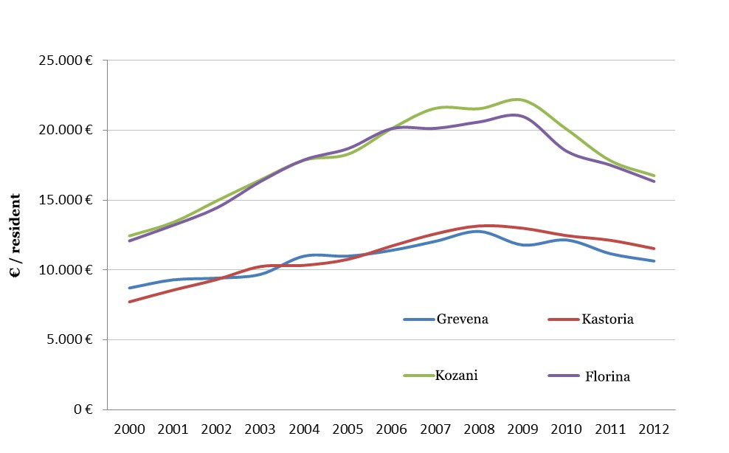
Figure 1.3: Per capita GDP in RWM per Regional Unit between 2000-2012, at current rates (ELSTAT)

Factors that hinder business activity include bureaucracy, the lack of access to funding, the political instability, the taxation system (regulations and rates of taxation), the inadequate infrastructures, the corruption, the restrictive labor regulations, the inadequately educated workforce and the diffidence for innovation.
The progress of all registered enterprises during 2008-2010 noted changes. Between 2009-2010, during the first two years of the economic crisis in the country, business deletions outweighed by 40% the corresponding business entries (1,826 versus 1,305 records deletions).

The key features of the Region per sector of economic activity
The key features of the Region per sector of economic activity are analyzed below.
As 49% of the production occurs in the secondary sector (2013), and the primary sector is limited to very low production rates, it is accurate to describe RWM as an industrial region of limited job sectors. This structure, which reveals the region's huge dependence on PPC’s activities, is unique throughout Greece. The main characteristics of each economic activity sector in RWM, as described in detail in the RIS3 plan of the region, are presented below.
The primary sector has been gradually shrinking over the past years. However, according to the RIS3 plan, RWM has the ability and potential to increase the contribution of the primary sector to the regional GDP (through restructuring, increasing production and improving vertical integration and standardization of agricultural and livestock products) and to job creation.
The secondary sector is dominated by lignite mining - electricity production activities (in the Kozani and Florina Regional Units), which share all the characteristics of a "monoculture". The fur processing and fur-bearing animal breeding sector (Kozani and Kastoria Regional Units) constitutes the second most important activity in the secondary sector of RWM.
The tertiary sector is defined by an important reduction in trade, since 2009, as a result of the economic crisis. Moreover, the insufficient exploitation of the natural capital and the cultural assets keeps the contribution of the tourism sector at particularly low levels. Despite its notable natural resources and the potential they offer in developing mild and alternative forms of tourism, the Region constitutes, by far, the less attractive tourist destination in the country, as it accounts for only 0.17 of tourist overnight stays per capita.
In the public administration sector, there is an unclear and partly modernized regulatory framework. Despite the efforts that have been made, it is necessary to obtain a public service with less bureaucratic obstacles, which will be able to promote and contribute to the development of competitive entrepreneurship, simplification of

procedures, improvement of production of public works and supply systems, development of regional monitoring and statistical analysis of development interventions, rational management and use of public property, improvement of workers' skills, planning and implementation of quality systems based on total quality management principles to provide high quality services and integration of ICT in the daily operation.
Generally, the Region of Western Macedonia faces structural weaknesses at its production system. The main characteristics of its economy is the limited range of sectoral specialization, the dependence on traditional industries, the very small size of the companies and the lack of investment particularly in R & D which are limited to 0.1% of the GDP of the region.

Employment
Based on the distribution of employment per sector within the Region, 16.53% of the active population is employed in the primary sector, 23.85% in the secondary sector and 59.61% in the tertiary sector. In absolute figures, employment per sector of productive activity in 2013 consisted of 14,579 employed in the primary sector, 12,033 employed in the secondary sector and 52,560 employed in the tertiary sector.
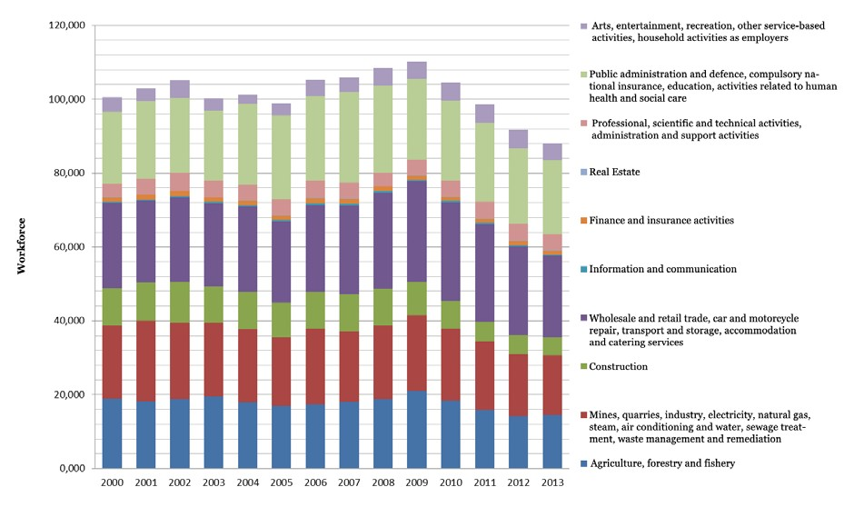
The distribution of employment of RWM's active population over time is presented in Figure 1.4 for the period 2000-2013. By examining the percentage change in the distribution of the active population per sector since 2008, the year of reference, until 2013, the largest drop is noted in the construction sector (-50.22%), followed by the Real Estate sector (-24.29%). An increase is noted only in the "Professional, scientific and technical, administrative and supportive activities" (+22.73%) and the "Arts, entertainment, recreation, other service based activities, household activities as employees" (+20.4%) sectors.
Figure 1.4: Sectoral distribution of RWM's workforce in RWM between 2000-2013.

Unemployment in RWM

According to Eurostat (2014), RWM ranks 9th in unemployment amongst all European Regions, with a 27.6% unemployment rate (22.4% for men and 34.6% for women, 25 respectively). More specifically, long-term unemployment (≥12 months) reaches 16.5% amongst the Region's active population (2014). Unemployment amongst young people up to 24 years was 70.4% in 2013, while in 2014 it appeared to drop significantly to 49.6%, an estimate which is nevertheless considered unreliable by Eurostat. The average annual unemployment rate per Regional Unit between 2001 and 2014 is presented in Figure 1.5. From 2009 onwards, there is a swift increase in unemployment in all Regional Units where data is available. Since 2011, there is a gradual decrease in the average annual total unemployment rate in the Florina Regional Unit. In the Kozani and Kastoria Regional Units there is a drop of approximately four per cent (4%) between 2013 and 2014. There is no data available for the Grevena Regional Unit.

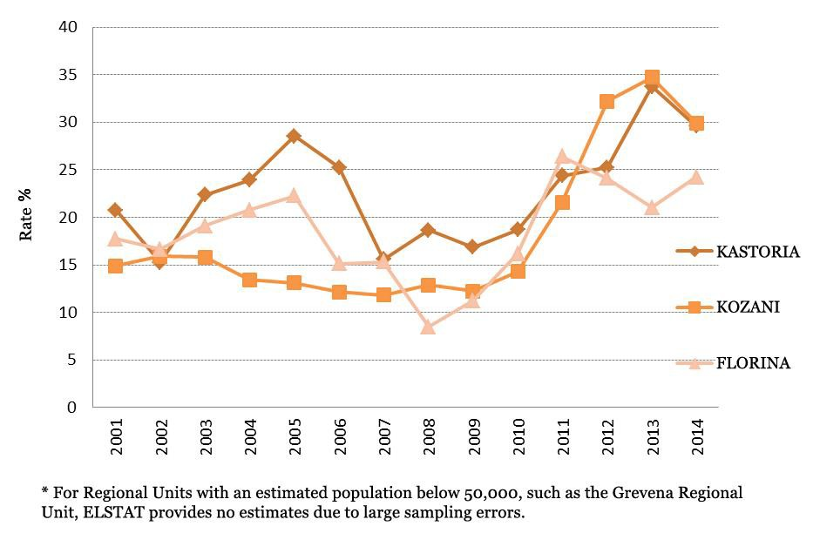
Figure 1.5: Average annual unemployment rate per Regional Unit between 2001-2014

The Region of Western Macedonia and Europe 2020 strategy
Interregional cooperation zones are identified in the fields of transport networks, energy and telecommunications infrastructure, and management of common natural resources and development opportunities of particular mutual interest (i.e. entrepreneurship, rural development, tourism, culture, health, education). The region of Western Macedonia in terms of the four key challenges (Globalization,

Demographic Change, Climate Change and Energy) as outlined at the "Europe 2020" Strategy is along with almost all of the EU Southern regions in a vulnerable situation and particularly regarding the Climate Change and Energy challenge.
In the framework of the "Europe 2020" strategy, the region of Western Macedonia should focus on a reorientation to new approaches in public and private investments, targeted to low-carbon economy and through strengthening territorial cohesion and cooperation to face common problems.

Summary
In summary, the current production structure of the region is not able to absorb the "shock" resulting from the crisis. Nevertheless, and in conjunction with the general policy measures that needs to be taken at national level the region should seek a production model that will be adapted according to its potentials.
The region of Western Macedonia in the current programming period has developed important working relationships with the neighboring border regions and with other regions in the European area that are identified as areas of common interest. The areas of cooperation at transnational and cross-border level, focus on the common problems and prospects, strong economic, social and historical - cultural ties, common natural resources, common or complementary infrastructures ensuring the interoperability and the planning beyond administrative boundaries.

The Digital Economy in Greece

In terms of the Digital Economy in Greece, the information available is mainly at a national level as the policies implemented until recently i.e. during the period 2007- 2013 were implemented at a national level. As such the information presented in this section concern county level information.
Focusing on the Greek case and especially on the national strategies for the next medium term period, the Ministry of Administrative Reform and e-Governance presents the main vision of the Greek e-government strategy for the period 2014-2020 which can be specified as follows: “Greece aims to build a more efficient, transparent and accountable administration, through the use of ICT and the support of the necessary governance and monitoring mechanisms, while maximizing constituent satisfaction, increasing participation and recovering confidence by offering constantly enhanced electronic services and promoting a new digital culture.” Within this context and given the crucial importance of e-governance for the efficient transaction of public administration with citizens and businesses, strategic priorities on digitization should be driven by several fundamental principles as presented below:
- Interoperability
- Compliance or justification
- Integration
- Conservation – Non recurrence
- Single data entry
- Feasibility – Sustainability
- Transparency – Confidence recovery
- E-Accessibility
- Security – Privacy
- Citizen Participation
Source: Ministry of Administrative Reform and E-Governance

In order to develop e-government and efficient ICT penetration within the public sector, recently the relevant policy makers in Greece have set the following general strategic goals:
Figure 2.1 e- Government strategic target (2014-2020), Source: Greek e-government strategy (2014-2020)

The following table describes digital projects in Greece of which their implementation has been recently undertaken, characterized thus as an ongoing process, or their implementation has been recently decided and it is expected to start in the near future.
More particularly, table 1 provides detailed information on recent digital programs with their actions, expected benefits, cost and the dates of design and start of implementation.

Table 2.1 Recent Digital Projects and Supportive Policy Actions in Greece

For the purpose of this study and the SKILLS+ project the priority focus is on Axis 2 – Investment Priority 2c – Enhancement of ICT applications in e-government, e-learning, e-inclusion, e-culture and e-health.
The policy's objective is to improve electronic services for citizens and businesses and addresses both SME and the public sector. About 10, 36 million Euro are available to finance e-solutions (ERDF) and 400k Euro for the enhancement of e-skills (ESF). The policy is part of the ROP of Western Macedonia, which is managed and implemented by PP4.
The policy contributes to the region's objective to become a "digital region" with innovative businesses. Funding from the programme is meant to be used to reverse the decreasing course of the business sector accelerated by the ongoing economic crisis, to address the consequences that come from an economically deprived region such as Western Macedonia is considered to be, and to improve the quality of life and innovativeness of business operations by taking advantage of modern ICT with regard to the region's SME, the policy shall contribute to create a "culture of openness, strengthening the development of tools for the promotion of the Greek enterprises and products through the internet, aiming to expand in international markets".
Despite the overall increase in broadband connectivity, access to both remote and rural areas still remain restricted due to high costs resulting from both the low population density and the aspect of distance. Businesses and citizens of peripheral parts of the region alike experience the negative impacts of the digital and broadband gap in relation to urban centres and the rest of Europe.

Greece’s Digital Economy Profile
Greece ranks 26th out of the 28 EU Member States in the European Commission Digital Economy and Society Index (DESI) 2016. Greece is part of the falling behind cluster of countries: its score is lower than the EU average and over the last year it grew at a slower pace than the EU. The Human Capital dimension (i.e. digital skills) is where Greece made most progress; however, levels of digital skills remain low and hamper developments in the Use of Internet by citizens, the Integration of Digital Technologies by businesses, and limit the take up of broadband. Moreover, the country is facing a severe emigration of intelligent, well-educated individuals. Greece is a moderate performer in terms of Digital Public Services with a level of active eGovernment users above the EU average.

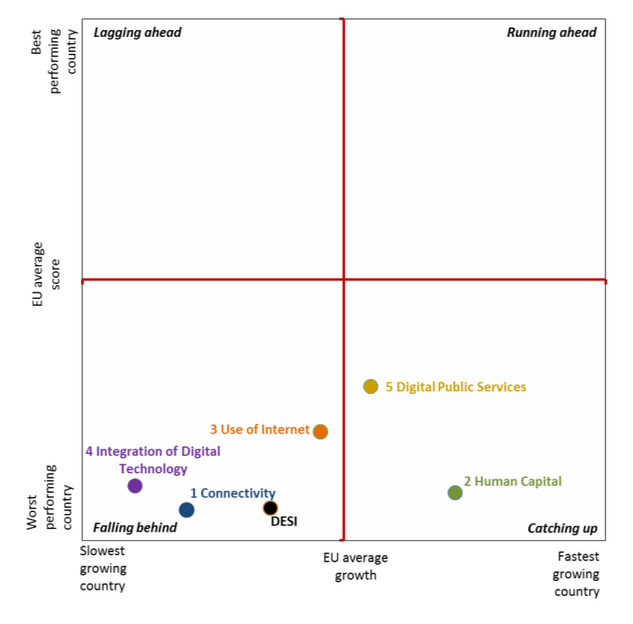
Figure 2.2 Greece's performance in the five DESI dimensions relative to other EU countries

Table 2.2 Greece’s Digital Economy and Society Index

 | rank | score | score | score
DESI 2016 | 26 | 0.37 | 0.44 | 0.52
DESI 2015 | 26 | 0.36 | 0.44 | 0.5

Integration of Digital Technology in Greece

Integration of Digital Technology covers (a) ‘business digitization’ and (b) ‘ecommerce’. ‘Business digitization’ has five indicators (as % of firms using): electronic information sharing, RFID, social media, eInvoices and cloud solutions. Ecommerce measures: the percentage of small and medium-sized enterprises (SMEs) selling online, ecommerce turnover as a percentage of total turnover of SMEs, and the percentage of SMEs selling online cross-border.
The adoption of digital technologies by businesses is a catalyst for economic development and labor productivity growth. While the ICT industry performed reasonably well during the economic crisis and is focusing increasingly on international markets, Greece's overall industry performance in integrating digital technology is below par and progress is slow. The percentage of businesses using technologies such as electronic information sharing (ERP – 37%) and social media (18%) is nearly equal to the EU average; however, not many Greek businesses use RFID, eInvoices, or cloud services. Very few Small and Medium Enterprises (SMEs) in Greece sell online (6.1%) and even fewer sell online to other EU member states (3.4%), probably because of delivery costs. On the positive side, the Greek start-up ecosystem is viewed very favorably worldwide and investments in digital companies have multiplied over the last few years, from €500 000 in 2009 to more than €50 Million in 2015. It is expected that a programme for "Upgrading of micro and small existing businesses to develop their capacity in new markets" will be issued under the OP Competitiveness - Entrepreneurship - Innovation of the National Strategic Reference Framework 2014-2020 (ESIF).
This programme will reinforce existing micro and small enterprises operating in eight strategic national priority sectors: agro-food, energy, cultural and creative industries, supply chain, environment, information and communication technologies (ICT), health - medicines and materials - construction. One of the proposed areas this programme will also cover is to support small enterprises in simplifying and automating operational and production activities through modernization of equipment and the introduction and/or increase of the use of ICT. It is important that Greek businesses improve their level of digitization in order to attain further efficiency and productivity gains so as to be able to benefit even more from taking advantage of the possibilities offered by online commerce. Greece would also benefit from an Industry 4.0 strategy as well as from European Fund for Strategic Investments (EFSI) dedicated funds for SMEs and larger companies.

Table 2.3 Integration of Digital Technology by business

 | Greece |  |  |  |  | EU
 | DESI 2016 |  |  | DESI 2015 |  | DESI 2016
 | value |  | rank | value | rank | value
4a1 Electronic Information Sharing  % enterprises (no financial sector, 10+ employees) | 37%  (2015) |  | 12 | 40%  (2014) | 7 | 36%  (2015)
4a2 RFID  % enterprises (no financial sector, 10+ employees) | 2.6%  (2014) |  | 26 | 2.6%  (2014) | 26 | 3.8%  (2014)
4a3 Social Media  % enterprises (no financial sector, 10+ employees) | 18%  (2015) |  | 11 | 17%  (2014) | 11 | 18%  (2015)
4a4 eInvoices  % enterprises (no financial sector, 10+ employees) | 4.1%  (2015) |  | 28 | n.a. | - | n.a.
4a5 Cloud  % enterprises (no financial sector, 10+ employees) | 6.5%  (2015) |  | 21 | 4.7%  (2014) | 25 | n.a.
4b1 SMEs Selling Online  % SMEs (no financial sector, 10+ employees) | 6.1%  (2015) |  | 27 | 9.1%  (2014) | 23 | 16%  (2015)
4b2 eCommerce Turnover  % turnover of SMEs (no financial sector, 10-249 employees) | 1.2%  (2015) |  | 28 | n.a. | - | 9.4%  (2015)
4b3 Selling Online Cross- border  % SMEs (no financial sector, 10+ employees) | 3.4%  (2015) |  | 26 | 4.3%  (2013) | 22 | 7.5%  (2015)

Table 2.4, 2.5 and 2.6 below represent the relative position of Greece on the key indicators of the thematic groups: a) ebusiness, b) digital skills, and c) ecommerce compared on a common scale with the lowest, average and highest European countries’ values. It allows to see how Greece is performing above/under EU average and more or less near to the maximum/minimum observed among EU countries. The original values are presented at the end of the bars for transparency, but they do not correspond to the length of the bar, because the latter is based on a standardized value.

Table 2.4 Country profile for Greece, eBusiness indicators
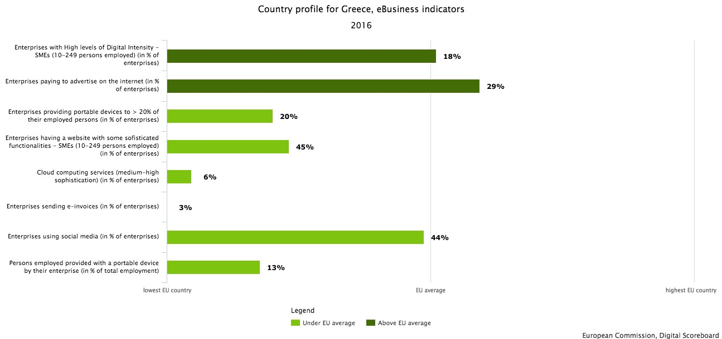

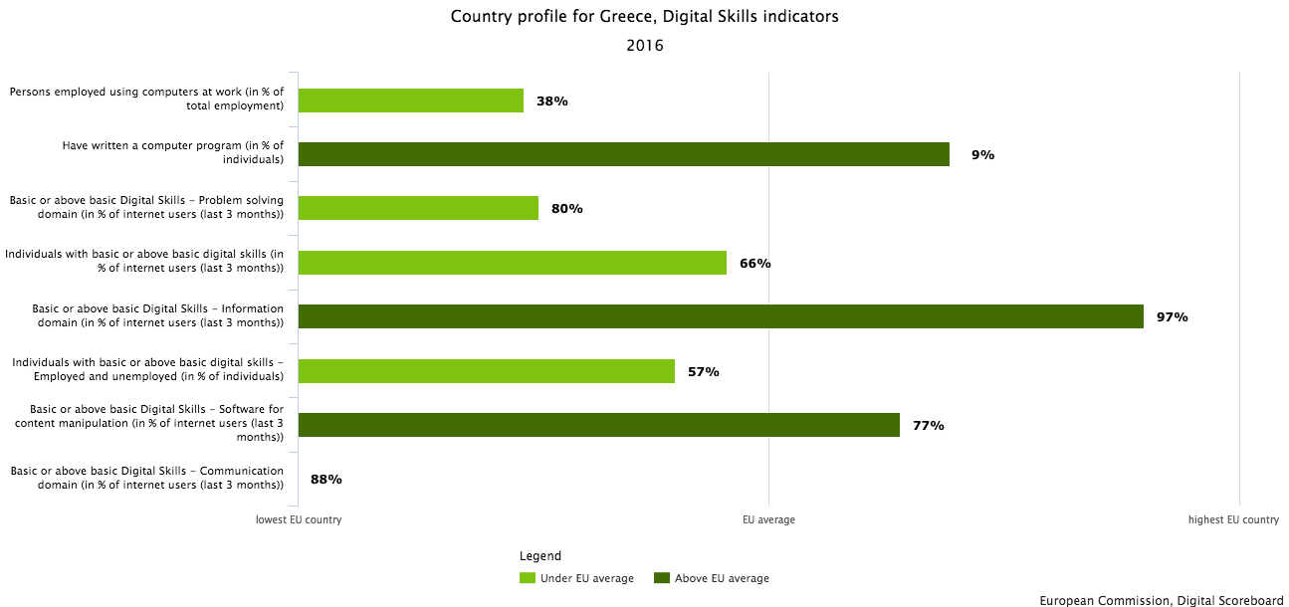
Table 2.5 Country profile for Greece, Digital Skills indicators

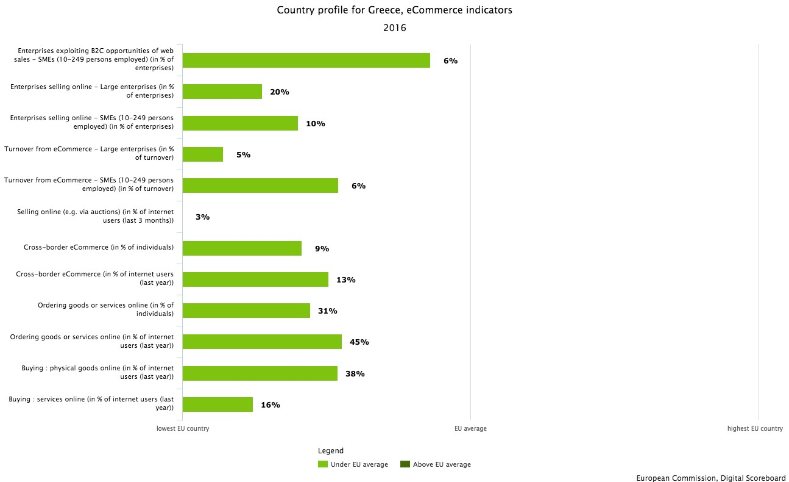
Table 2.6 Country profile for Greece, e-commerce indicators

Table 2.7 Summary of ICT development indicators for SKILLS+

Indicators | 2010 | 2011 | 2012 | 2013 | 2014 | 2015
Percentage of the ICT sector from GDP, % | 2,13 | 2,06 | 2,04 | 1,98 | 1,84
Percentage of workface working in the ICT sector, % of the total employment | 1,28 | 1,33 | 1,44 | 1,32 | 1,43
Percentage of SMEs selling on-line, % | 8 | 6 | 7 | 8 | 9 | 6
ICT specialists in enterprises, total |  |  | 35 |  | 24 | 26
Enterprises which provide any type of training to develop ICT related skills of the persons employed, % of SMEs |  |  |  | 16 | 13 | 17
Enterprises with broadband Internet connection, % of SMEs | 81 | 82 | 80 | 78 | 87 | 85

Indicators | 2010 | 2011 | 2012 | 2013 | 2014 | 2015
Use of computers, Internet and web sites in enterprises, % of SMEs | 58 | 64 | 64 | 61 | 62 | 61
Employees using computers and computers with internet connection in their job regularly, % of employees of SMEs | 35 | 35 | 37 | 39 | 39 | 38
Use of social media in enterprises, % of SMEs |  |  |  |  | 35 | 34
Individuals using the internet for ordering goods and services, % of individuals aged 16 to 74 | 12 | 18 | 20
Individual’s level of computer skills, % of the total number of individuals aged 16 to 74 |  | 9 | 8 |  | 13
Percentage of individuals, which have never used the internet, % | 52 | 45 | 42 | 36 | 33 | 30
Percentage of individuals having above basic digital skills, % |  |  |  |  |  | 28
Source: Eurostat, 2017

Characteristics of ICT in Western Macedonia Region
The region of Western Macedonia is ranked in low positions in relation with the European averages regarding all indicators related to ICT, both at the level of public services to citizens and to businesses. Greece, compared to the other member states - still ranks low on all indicators relating to the Digital Agenda 2020 (Digital Agenda Scoreboard 2012). From the few indicators that are available, it appears that Western Macedonia in 2011 significantly lags behind in relation with the European Average for the frequent use of the Internet (Western Macedonia 44%, EU27 68%) and the purchases via the Internet (Western Macedonia Region 15%, EU27 45%).
The extent of ICT use by SMEs is considered as static in recent years, unsatisfactory and with low IT maturity. Based on survey data by IS SA, 2012 (RIS3 plan of Western Macedonia), the level of ICT use by SMEs in Western Macedonia is below

the National Average in most criteria and much lower than the EU Average i.e. the percentage of companies that save 50% - 75% in terms of time due to real digital transactions in addition with the traditional methods with the public sector is for the region of Western Macedonia 14.7 versus 20.9 of the National Average and 30, 3 of the EU average.
Demand for ICT products and services in the Region of West Macedonia are extremely low, due to low income, and the lack of “digital” skills in the population. According to the “Internet Users in Greece” survey (March 2010)1 of the Observatory for Digital Greece², PC usage and use of the Internet had reached 32% of the regional population. These figures are a clear indication that the ICT penetration is at a good level, always compared to other Greek Regions.
Despite the overall increase in broadband connectivity, access to both remote and rural areas still remain restricted due to the high costs resulting from both the low population density and the aspect of distance. Small populations seem to pose a restriction upon the exploitation of scale economies and entail a lower degree of demand and a limited investment expected return. Investments for setting up broadband facilities in such areas have proved to be inadequate in many cases. Within this framework, wireless networks can bridge the digital gap since these networks require a lower need for technological investments.
As a result, municipalities, citizens and enterprises in remote and rural areas, all experienced the negative impacts of the digital and broadband gap in relation to both the National and European Core. Undertaking the initiative to cover the demand for broadband access even that of the most isolated citizen in the region, is a one-way option. This could be achieved by:
    - Broadband coverage up to the most distant rural locations.
    - Supporting Local Government’s Broadband Service.
    - Provision of Public Services even to the most remotely located citizen.
    - Supporting entrepreneurship by creating new firms based on wireless technology.
    - Encouraging innovation and creating employment opportunities.
    - Familiarizing citizens in remote and rural areas with new technologies.
    - Making broadband services available to remote and rural areas support local communities in attracting investments and improve their public and

1 Ταυτότητα χρηστών internet στην Ελλάδα”, Παρατηρητήριο για την ΚτΠ, Μάρτιος 2010. http://icteval.ktpae.gr/stats/delivery/
² The Observatory for Digital Greece was a program funded by OP “Digital Convergence” 2007-2013
educational services. Furthermore, the application of broadband communication will allow these areas to provide e-health and tele-working services.

A quite small number of ICT SMEs are present in the Region, focusing on system integration, maintenance, and software support for state agencies and for the retail sector. The Region also hosts one University, one Technological Institute and a research institute, with ICT-related departments.
The Region suffers from considerable and prolonged drain of talented ICT professionals, as the relevant jobs are limited. The young ICT graduates of the local higher education institutions are normally moving to other regions, thus creating additional challenges to any recovery effort.
According to the preliminary strategic directions of the Region of Western Macedonia, the following sectors are best suited to benefit from modern ICT tools and technologies:
Agriculture and animal husbandry: represents a significant portion of the regional economic activity, with sizable growth potential, if combined with modern ICT tools. The Region could focus on distinct products (like Krokos of Kozani) that exhibit proven demand from international markets. The related business units should be encouraged to become more efficient by accommodating modern control, administration, monitoring, marketing, and logistics tools. Added value bio agricultural and alternative agriculture producers can benefit from internet-based marketplace participation, to widen their distribution channels and optimize branding, procurement, packaging etc. Farmers and livestock unit owners could also be supported to optimize their production activity, by employing modern control and monitoring tools, especially in reducing the cost of energy by using alternative methods, like geothermal resources or biogas.
Food & Beverages: SMEs in food and beverages may improve their profit margins and boost their sales by better branding and advertising, using new-generation ERP and CRM tools, along with e-commerce and procurement platforms.
Energy: the Region produces 45% of the national electricity demand. This huge industry requires several support and maintenance services, offered by SMEs, to cover specialized needs of the production sites. The Region would provide incentives to attract the ICT related SMEs, able to improve the employment profile of the Region.
Tourism: although tourism represents a small portion of the current economic activity, it should be underpinned, due to the fact that the Region has numerous areas of natural beauty and unexploited archaeological and religious sites, capable of attracting a significant number of visitors. SMEs should be motivated to exploit

Modern technology and synergies to maximize the outreach of the Region, minimize management and advertising costs, and thus create more and better jobs.
eGovernment and learning: the low level of IT skills in the Region implies that the cost of dealing with the regional public services is enormous for both citizens and regional and national government. Properly designed and interoperable e-government apps would be a major contribution towards efficiency and transparency. These services could be easily combined with proper initial training applications, to overcome the barriers of low IT skills.
Health: health services are beyond reach for several citizens living in remote mountainous locations. This problem can be partially solved by using new telemedicine or home-care services. The Region should provide support to the private sector, to deploy affordable telemedicine or home-care platforms, for selected classes of citizens. These services would be provided as public-private partnerships (PPPs), in cooperation with local state hospitals and health centers, under a proper sustainability model.
Broadband Internet: the availability of affordable broadband connections for all the households is a major European target. The Region should complement all the related national- and EU-level actions, to further extend broadband availability and take-up in the Region. More specifically, it should help making local Industrial Zones/Parks as “FttH-ready”, i.e. bringing fiber to each hosted enterprise. The same can be done for selected neighborhoods, by connecting the respective households with a passive “open-access” FttH local network. It is also crucial to facilitate additional actions like setting-up of public free-access hot-spots in public places, schools, sports/recreation areas, churches, etc. The Region should also investigate ways to improve the utilization of existing MANs, and provide proper incentives for the expansion of next generation cellular networks (e.g. LTE) in the Region.
Furthermore, the Region may prepare a versatile mechanism, tailored for its particular size and needs, for the substantial involvement of the private sector in the full cycle of project execution and risk sharing. This can be better carried out by flexible PPPs, or by the establishment of targeted ICT Vouchers for selected households or SMEs.
Although the RIS 3 priorities regarding ICT have been recognized the follow up measures are still lacking. Specifically:
  - There is currently no detailed regional ICT strategy per sector. In many cases, there may be a balanced allocation, in order to achieve better economies of scale.
  - There is no master plan for e-government services. Most of them (cadaster, ePrescription, e-invoicing, etc.) are administered by national authorities and, therefore, should be better addressed by a balanced allocation. Other possible eservices, like local taxation or regional permits, would be administered by the Region. All e-government services should adhere to well-defined interoperability standards, and be based on dependable cloud computing platforms3.
    - There is no reference to viable plans for the deployment of new, and the extension of next generation access networks.
    - The Region should prepare the creation of an inventory of ICT infrastructure.
    - Active involvement of the private sector in ICT activities has to be addressed by the Region, in a way to both leverage public funding and improve sustainability of ICT investments.
The most recent available statistics regarding indicators on ICT for the Region of Western Macedonia are provided below.

Table 2.8 RWM ICT indicators

Broadband
Indicators
Unit

How many families have a broadband connection at home | 63%
How many enterprises (10 employees at least) have a broadband connection for own activity | 69.5%
How many Public Authorities have a broadband connection | 100%

ICT into the Public Administration -

Indicators | Unit
How many local PA (municipalities) manage through PC
- Personnel | 95-100%
- Accounting | 95-100%
- Payments | 95-100%
- Contracts | 35%
- Calls | 12%
- Registry office | 95-100%
- Administrative acts and resolutions | 40%
- Taxes | 65%

3 7 http://ec.europa.eu/information_society/activities/cloudcomputing/docs/com/com_cloud.pdf

Internet and the citizens -

Indicators | Unit
- Email | 82%
- Searching info on products and goods | 70%
- Searching info on travel and holidays | 70%
- Searching health info | 4%
- Other search activities | 45%
- Learning | 6%
- Downloading | 58%
- Home banking | 14%
- Blogging | 31%
- Chat / communities | 35%
- Phone | 16%
Focusing on people which purchasing by Internet, how many buy
- Travel, holidays | 38%
- Films, music | 15%
- Software | 10%
- Tickets | 45%
- Hardware | 31%
- Electronic devices | 60%

Internet and the enterprises -

Indicators | Unit
How many enterprises (10 employees at least) use Internet for:
- Commerce (buying/purchasing) | %*
- Banking or financial services | 43%
- PA services | 78%
- Achieving market information (e.g. prices) | 56%
- Achieving digital information and services | 32%
- E-learning | 6%
How many enterprises (10 employees at least) have a web site | 65%
Which services/information they offer by the web site:
- Catalogues and prices | 55%
- On line purchasing / booking | 20%

Indicators
Unit

- On line payments | 19%
- Working request | 21%
- Product customization (by customer ) | 20%
How many enterprises (10 employees at least) use ICT for data management. Example:
- Receiving digital invoices | 8%
- Sending digital invoices | 20%

Main Stakeholders of CCI of Western Macedonia Region

Different types of stakeholders are identified and interviewed to evaluate the current use of digital technologies by SMEs in rural areas. A list of identified groups of stakeholders and a justification for their selection is presented in Table 3.1.

Table 3.1 List of Stakeholders selected for the SKILLS+ project

Stakeholder institution (*) | Justification
Managing Authority of ROP Western Macedonia | Regional Policy instrument holder on behalf of the region, as ROP 2014-2020 managing organization.
Municipality of Prespes | Representative stakeholder from rural areas (cross border area)
Municipality of Grevena | Representative stakeholder from rural areas
West Macedonia Technological Educational Institute | Representative stakeholder from the academic and research sector
Chamber of Commerce of Kastoria | Representative stakeholder from the business sector (rural area)
Business Experts | Representative of the business sector- freelances
Cosmote SA (tbc) | Representative of the business sector (telecommunication company)
Forthnet SA or Business Expert (tbc) | Representative of the business sector (telecommunication company)

The results of the survey are presented in Annex A.

Regional Policy: drawbacks and Initiatives for digitalization of SMEs
This section describes how ICT is linked to the regional innovation strategy for Smart Specialization. The general objectives of Priority Axis 2 of ROP 2014-2020 and

Priority 5, of RIS 3, of Western Macedonia regarding the digitalization and utilization of ICT in the region, are:
- the creation of conditions for the differentiation of the rather dependent on the energy sector production base, and adaptation of local standards and
- the improvement of existing services to citizens with a parallel exploitation of ICT.
The above is expressed by two action lines:
- Improvement of productivity of the region through the use of ICT via (a) the promotion of the use of ICT in enterprises of the region, (b) the provision of e- services to enterprises and re-design of local governance procedures, (c) the enforcement of the ICT sector in the regional economy and (d) the promotion of local entrepreneurship in ICT intensive sectors
- Improvement of the quality of services, through the a) improvement of daily life through the use of ICT – equal participation of all citizens to Digital Greece and b) the development of local e-government services for citizens
Specific goals that derive from the above action lines, are:
- Differentiation and enrichment of the productive base through the adoption of innovation and the improvement of competitiveness of firms;
- Development of research and technology at an entrepreneurial level with the cooperation of educational and entrepreneurial stakeholders and the introduction of new production methods;
- Develop participative web services with modern approaches, in which people comment, submit opinions, interact with each other, but also create and contribute content (e.g. user generated content, events-actions);
- Design and implementation platforms that will allow citizens to request information and report problems;
- Increase of the added value of the energy sector by improving its connection to the local productive system;
- Enforcement of entrepreneurship support structures and of infrastructures for attracting businesses;
- Development of ICT applications in the public sector and local governance; and
- Development of ICT structures and infrastructures with access from all citizens.

Barriers to efficient implementation of Digital Actions in Greece
The design or redesign of a national digital strategy in Greece requires first the identification of the main weaknesses and failures of past attempts regarding the stimulation of digital growth. As in almost all countries focusing on the support of

ICT adoption in businesses, citizens and public sector, this effort was accompanied by failures. In Greece the failures were added to the rigidity and bureaucracy that characterize the operation of the public administration, generating cumulative pathogenesis, delays and lags. Within the context of the National Strategic Reference Framework (2007-2013), fostering ICT use was a main concern of the Greek government. However, some general obstacles have observed to the efficient adoption and implementation of relevant supportive operational programmes (such as the “Digital Convergence”) related to the stimulation of ICT use and digital growth in Greece. In this respect, the main factors hindering efficient adoption of ICT in businesses, citizens and public sector are the following:

- Policy-driven limitations
  - Limited political willing to stimulate digital growth and e-government
  - Inadequate planning and funding throughout the life-cycle of information systems
  - Limited actions related to the reuse of public information and data
  - Inefficient mechanisms of horizontal government schemes
  - Discontinuity of adopted policies at every governmental change

- Weaknesses related to technical design and planning
  - Lack of interoperability and interconnection among the information systems of the public sector
  - Lack of a common architecture in public sector computing, absence of common standards and compliance policies for ICT use
  - Low exploitation of ICT infrastructures, business segmentation of systems, high dispersion and operational overlaps in the information systems of the public administration - Weak networks between public and private sector in ICT solutions
  - Complexity and lack of simplification in the relevant institutional and regulatory framework

- Obstacles to efficient implementation of ICT adoption
  - High cost of introduction and use of electronic infrastructure, mainly due to the lack of appropriate programmatic agreements and licenses covering the needs of the public administration
  - Complex projects and infrastructures characterized by managerial and operational limitations implying a negative cost-benefit nexus
  - Time-consuming public procurement processes (due to significant delays in the stages of tendering, auctions, awarding etc.) overcoming the lifecycle of procured ICT products/services, resulting thus the introduction of old- fashioned products
  - Lack of efficient monitoring, evaluation and feedback in ICT activities

  - No motivation to public servants serving in ICT roles to be engaged in the process of EU funded projects
  - Lack of expertise in public servants serving in ICT roles to effectively support the process of EU funded projects

The challenges that the Western Macedonia businesses face
The main body of Western Macedonia businesses is consisted mainly by ‘micro’, ‘small’ and very few ‘medium’ businesses. Despite the fact that innovation and exploitation of RTD is inherent mainly in the medium - large companies, it is often observed that medium businesses in the region of Western Macedonia (even if they are limited in number) show some potential towards innovation. The business survival conditions leads SMEs of all sectors (and often micro companies) in a constant search for ways to develop and expand, sometimes using the flexibility that gives them the small size of their company, and the authenticity that depends on local restrictions.
Despite the fact that business in most of the sectors in Western Macedonia seem to ignore the role of research and development, as a structural element of any business (and to some extent this is justified by the size of the business), it seems that they do not completely lack of innovative initiatives. Several national policies and programs supporting innovation that were designed and implemented in recent years, have funded businesses that eventually showed progress by investing in innovation, despite the negative economic conditions.
Since the vast majority of the region's businesses are very small family units the number of employees is usually very small (i.e. 10 people). The existence of a single graduate in this size of business, recommends a low level of innovation capacity, regarding human resources. The reality is that in many of these very small units (and it mostly occurs in the last 10-15 years) is one graduate (usually from the family environment of the business owner), but the mobilization towards innovation depends largely on the work environment.
The kind of innovation in which the micro and small enterprises in the region invest is mainly the improvement of products (appearance, packaging, etc.), and secondarily the improvement of the existing technology (with small investments in production line).
The design of new products and services clearly has little impact on micro and small enterprises in all sectors, as it requires high investment and has greater risk, in contrast to the production process which seems to be one of the main strategies for innovative business. On the other hand although there is a small number of medium enterprises in the region, this kind of enterprises choose reluctantly and systematically to show their presence in their sector through innovations in the design of new products, the production process but also in the package in order to achieve high growth rates.

In the tertiary sector, service based business face many challenges regarding their strategies towards innovation. One of the main restrictive factors for innovation for a service company in Western Macedonia is the required financial resource. The cost of innovation and the availability of the required capital is most of the times a prohibiting factor for innovation. Other prohibiting factors include the bureaucracy, the regulatory framework, as well as the absence of incentives from the public sector as policy support to the industry.
The high cost of innovation and the lack of required funds reasonably lead to search for funding partners, which in the case of micro and small enterprises in Western Macedonia have a clear preference to identifying EU funding. Indeed, SMEs seem to prefer direct financial support from the EU (and secondarily by the state) at very high rates. The lack of tax incentives also seems to affect greatly and in a negative way the innovation of SMEs.
The main deficiencies and gaps that exist in the region’s SMEs are identified in the following areas:

Extroversion
Inflexibility of the regional enterprises towards export trade, which is mainly due to the lack of national and less due to the regional strategy on export -policy, is observed. The Export Promotion Organization has undertaken the promotion of Greek products abroad with very low budget which does not meet the needs for the improvement of competitiveness in the global markets.
The lack of dynamic in exports degrades the image of the Greek products abroad. Additionally to this effort it seems that the involvement of industry representatives in the planning, coordination and implementation of policies is very limited.
Furthermore, for the region of Western Macedonia the small size of the businesses (their quantitative production capacity) is another inhibiting factor in the export operation mechanism.

Partnerships
The disadvantage of the small size of businesses should be offset over time through cooperative movements. Today, business networking in all sectors is almost nonexistent (with few exceptions) at business level and vertically in the production chain - trafficking - distribution.
The business segmentation is an obstacle to exports, worsens the economic cost of the development and does not help in solving problems that are mainly found in the relations between the businesses and the retail.
It has been proven internationally that the cooperative movements can promote synergies in issues like the cooperation with research units and the operation quality control laboratories, so they can also lead to scale economies.

For example, the development of economic production, packaging and marketing of quality goods with special local identity can support the diminishing primary sector in the production of quality, certified and organic agricultural and livestock products. Production activities of this type, orientated to the local community through cooperative schemes, compose one of the key aspects of the social economy. These are actions, as well as new production directions, assisted by funding instruments, national and co-financed, with favorable conditions in the economy of the region due to the dominance of the service sector and its significant assets.

Electronic commerce
The exploitation of internet in order to meet the needs of the businesses is more and more necessary for the improvement of the export process of the SMEs (participation in global markets, e-marketplaces, automation of transactions, creation of electronic markets of suppliers and promotional activities worldwide)
The lack of policy and the existence of many obstacles for the investments in the sectors of information and communication do not create a positive digital environment for business.

Quality and product safety (in regional economic sectors)
The healthy competition ensures consumer protection and precludes malpractices connected with the relaxation of vigilance for the safety of products. The imposition of traceability to the raw material producer ensures better control of the final product. The consumer’s awareness and its strengthening both help in providing high quality products and standards, as well as to boost competitiveness.
There is a great lack in the awareness and training of businessmen about new quality improvement techniques and internationally recognized safety standards.

Innovation
The small size of the businesses, the administrative and organizational deficiencies, the risk-averse culture limit the innovative actions in the sector.
The intervention of the State is necessary on issues like the copyright protection, the more favorable taxation, the introduction of innovation awards and the adequate funding for R & D.
The organizational and administrative modernization of the businesses and partnerships of public and private entities for the minimization of the uncertainty implementation of research results, are actions that will facilitate and improve innovation in all business areas.

Institutional issues
They are recorded over time institutional gaps and problems in the business sector.
At the same time there is an institutional gap in the observation of the implementation of the Community quality regulations and in the market control. The regulatory framework includes laws and regulations that need to be adapted to current conditions, while the Greek legislation is not fully harmonized till today with the European legislation.

Support available to businesses wishing to upscale the use of digital tools
The most notable ICT projects that have been implemented in the recent years and have facilitated the use of digital tools are concerned with the implementation of metropolitan access optical networks (MAN) and municipal wireless hot-spots, the development of content for the disabled, digitizing of cultural content, and the networking of the higher education institutions and the school units to the national research and education network and the Internet.
The most important ICT and digital developments in RWM are mainly the following:

- Broadband connectivity infrastructure (2007-2016)
    - The project was supported by ERSF, OTE SA and other private companies
- The national action called Digi-Content who supported Greek enterprises develop Information and Communication Technologies (ICT), in order to implement investment plans on digital broadband content
- The project was funded by the intermediate body “Digital Aid S.A.” within the framework of the “ Digital Convergence” Operational Programme (OP-DC) of the National Strategic Reference Framework 2007 – 2013 (NRSF 2007 – 2013).
- The national action called Digi-Lodge that supported Greek hotel sector develop Information and Communication Technologies (ICT), in order to establish promotion websites and online reservation systems
- The project was funded by the intermediate body “Digital Aid S.A.” within the framework of the “ Digital Convergence” Operational Programme (OP-DC) of the National Strategic Reference Framework 2007 – 2013 (NRSF 2007 – 2013).
- The national action Digi-Retail that supported Greek retail enterprises develop Information and Communication Technologies (ICT), in order to implement investment plans on general digital investments
- The project was funded also by the intermediate body “Digital Aid S.A.” within the framework of the “ Digital Convergence” Operational Programme (OP-DC) of the National Strategic Reference Framework 2007 – 2013 (NRSF 2007 – 2013).
Furthermore the new ROP 2014-2020 provides a supportive framework for increasing the use of ICT and achieving higher productivity in the economy. The ROP 2014- 2020 specifically addresses the digitalization issues with the following priorities.

Priority 1: Improved productivity & innovation through the use of ICT.

    - improve ICT penetration in production processes combined with the development of innovative business practices (priority is given to RIS3 main areas i.e. fur & fur industry, environment / energy sector incl. “green” businesses, exploit tourism – culture); and
    - Increase the use of ICT in day-to-day company operations.
Priority 2: Improvement of citizens’ daily life through the use of ICT and “connect” them to SMEs
    - increase availability of digital public services;
    - streamline and digitalize the most frequently used public services (especially the services included in the strategy “i2010”);
    - encourage citizens to take part in community activities through the development of ICT applications targeting NGOs; and
    - promote the cultural heritage of the region through the use of ICT.

Main driving forces in the digitalization of rural SME’s business activities

The main driving forces for the digitization of rural business activities of SMEs derive from the regional policies as defined in the ROP 2014-2020 and RIS 3 of Western Macedonia. Further to these policies other driving forces include:
      - efforts for internationalization and exports
      - effort to reduce operating costs
      - effort for working conditions improvement
      - attempt to reverse the bad investment climate in Western Macedonia

SWOT analysis
The SWOT analysis conducted in this section is directly connected with the topic of up-scaling ICT skills and tools used by SMEs

STRENGTHS  Qualified human resources; Quality products of the primary sector; Higher Education Institution – Department of Informatics Telecommunication Engineering; Telecommunication infrastructure; Experience of stakeholders; Cross border business opportunities | WEAKNESS  Lack of regional policy for RTDI; Limited spatial entrepreneurship; Low specialization / insufficient connection with educational and research institutions; Lack of business networks; Low development of ICT applications; Business Size / Absence of business directions; Lack of structures for supporting entrepreneurship and ICT; Lack of investment; Financial deficiency
OPPORTUNITIES  Europe 2020 - NSRF 2014-2020; Implementation of RIS 3 identified; Priority 5: Digital Convergence and Entrepreneurship; Integration in the production of new economic activities; ICT Infrastructure development; Digital Single Market; Interoperability & Standards; Trust & Security; Fast and ultra-fast Internet access; Research and innovation; Enhancing digital literacy, skills and inclusion; ICT-enabled benefits for WM region | THREATS  Extension of the bad economic conditions; Limited response of the stakeholders in RTDI actions; Limited application of RTDI and ICT in the production area; Low competitiveness; High unemployment; Decreasing industrial activities

Analysis and identification of main regional experience and lessons learnt/ Good practice assessment
This section provides an analysis of the selected Good practices of the Region of Western Macedonia. Furthermore, it provides an assessment of selected Good practices identified in partner regions in order to identify potential means of adaptation and implementation opportunities.
There are three examples presented in this section that describe relevant digital developments in Greece.

- DIGI-LODGE. “Aid for accommodation establishments, to create websites and computer reservation systems (digi-lodge)”
Description: The Action “Aid for accommodation establishments – creation of websites and computer reservation systems (digi-lodge)” referred to the implementation of investments in tourism section by enterprises that operate as hotels or accommodation establishments. The Action aimed at:
- The international projection of Western Macedonia
- The reduction of seasonality and extending the tourist season
- The adoption and use of modern tools of ICT by the hotels and accommodation establishments
Accommodation establishments and hotels were supported by this Action in order to develop new applications on web promotion and communication including computer reservation systems. The completion of the project included also the use of existing or new systems of best computerization practices of hotels and accommodation establishments. The action was approved for funding in 2010 and the project run until 2013.
Localization: Regional Level
Responsible Body &contacts: Information of Society SA (http://digilodge- portal.digitalaid.gr/Default.aspx?aspxerrorpath=%2F)

- Wines of Crete - A portal that brings together the place, the wines and the visitors
Description: Wines of Crete is a portal that brings together special products of the island: tourist and wine. It aims at the consistent promotion of Cretan wine not only within the island but to other places as well. The main objectives of the whole action are:
  - The promotion and recognition of Cretan wine, both inside and outside Greece now, and
  - The development of wine-tourist mainstream on the island, taking advantage of a series of 'tourist' advantages the island displays.
The portal provides information on Cretan wines (varieties, wineries, history of wines in the island), alongside with the information on the island as a tourist destination (history of Crete, maps, wine tourism, local gastronomy and Cretan diet). It is an effort to present Cretan Wines and their place of origin as indivisible whole.
Localization: National level
Responsible Body &contacts: http://www.winesofcrete.gr/.
Wines of Crete, Archimidous1 & Ikarou st., 716 01 Nea Alikarnassos, Herakleion, Crete, T: +30 2810 300 688 Contacts and info:
http://www.winesofcrete.gr/cretewines/en/Article/%CE%95%CF%80%CE%B9%CE
%BA%CE %BF%CE%B9%CE%BD%CF%89%CE%BD%CE%AF%CE
%B1_1011.html

- “Digi-Retail”: Providing financial aid to retail companies with a view to making digital investments (Digi-Retail)
Description: The action “Providing financial aid to retail companies with a view to making digital investments” (Digi-Retail) is related to “digital aid” provided to retail companies so that they can make good use of new technology tools for their development and in order to face the negative impact caused by recession and the changing attitude of customer habits. The action took place during 2011 – 2012. Digi-Retail aimed to enhance retail enterprises and support them develop new technological tools in order to cope with the negative effects of the current financial crisis and with any consumer’s behavioral changes because of it.
Localization: National level
Responsible Body &contacts:
http://digi- retailportal.digitalaid.gr/web/guest/;jsessionid=C3FFADEC692164747993B10698E5 CA3B

D) Rural Broadband: "Development of Broadband Infrastructures in Rural" Territory"

Description: In December 2016, the OTE Group is launching a commercial fast-paced Internet and broadband service in 2,247 remote locations, serving more than 320,000 residents (in northern and southern Greece), as part of the Rural Broadband project. Citizens who live in rural, mountainous, insular and inaccessible areas of Greece may now have access to fast internet services, as they are connected to VDSL connections with speeds of up to 50Mbps, enjoying all modern services, VoIP, IPTV, VoD, Small Business & Enterprise Broadband Services, e-commerce, telemedicine, tele-education, etc. on equal terms with other citizens of the country.

The main purpose of this major project was to co-finance private companies to develop new infrastructures in sub-served ('white' and 'grey') areas of Greek territory in order to provide high-quality broadband services to the general public. At the start of the planning of this action (early 2005), the country's geographic and population coverage by broadband services ranged between ~ 13% and ~ 60% respectively and the objective was to increase this coverage so that after the completion of the project it exceeds 60% and 90% respectively.

This practically means new opportunities for all the fields of tourism, digital governance, trade, transport, information, entertainment, security, health, education, agricultural crops and the promotion of local products, exports and promotion of Greek enterprises, environmental protection, culture and a series of interacting fields of economic and social activity.

In detail, the overall network includes the following elements:
- Access network: Ensures high-speed broadband access - Bitstream (up to 50M / 30 Mbps) to end-users through Sub LLU subnet.
- Access node for multiplex join: VDSL DSLAM installation to typically serve a settlement or in some cases several settlements.
- Reverse link network: interconnects the Access node for multiplex join with the Regional Interconnection Node (RIX).
- RIX: The main point of interconnection of third Providers with the Rural network.
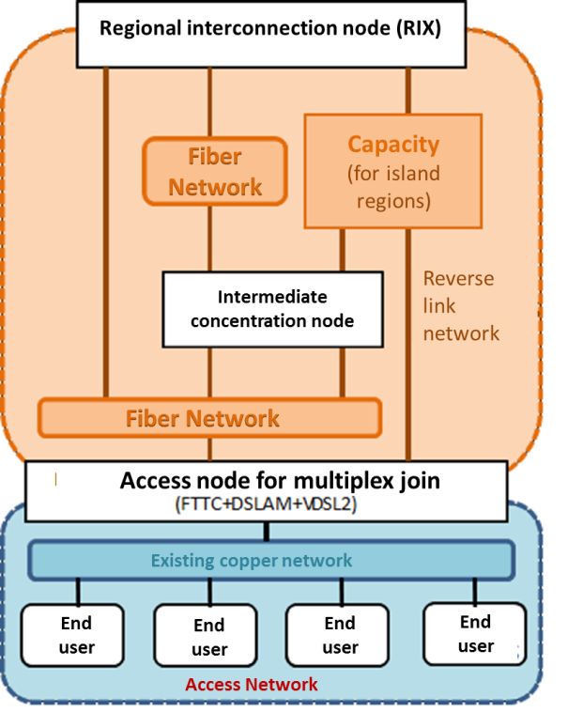

The total investment for its implementation amounts to € 113 million, of which € 101 million come from national and EU funds.

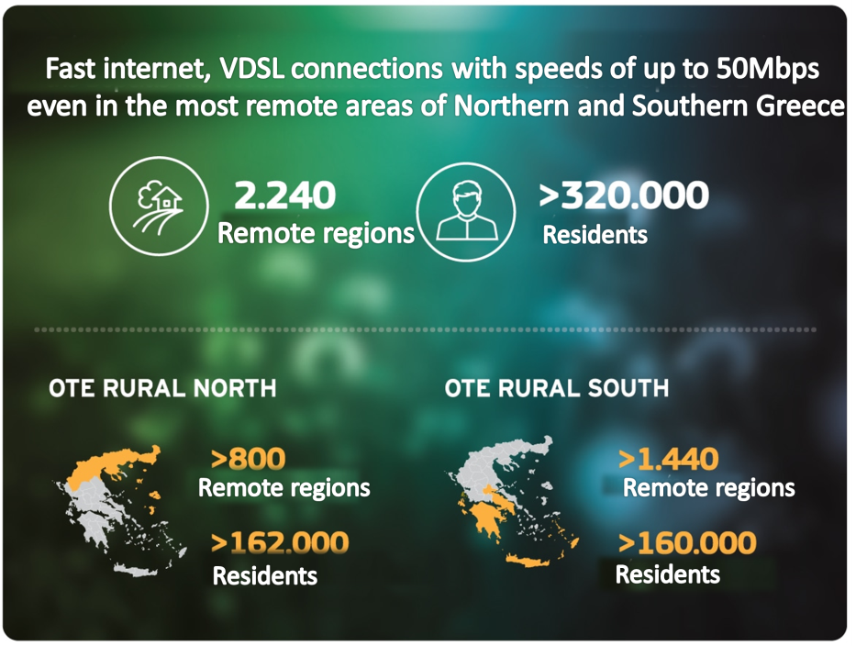

The project "Development of Broadband Infrastructures in Rural" White areas of Greek Territory" was designed by the General Secretariat of Telecommunications and Post, implemented by the Information of Society SA (IS SA) and co-funded by the NSRF.

Localization: National level
Responsible Body &contacts: Information of Society SA (http://www.oteruralnorth.gr and http://www.oteruralsouth.gr )

Selection of good practices from other SKILLS+ partner regions
A selection of Good Practices is made considering parameters such as usefulness and applicability in the local conditions of the RWM. An initial assessment is presented in Table 6.1. The assessment is based on a preliminary screening of the characteristics of the good practices. However, the final selection of the good practices that will be included in the regional action plan of the RWM will be decided after the interviews of stakeholders are performed.

Table 6.1 Assessment of Good Practices Selected

 | PARTNER | SKILLS+ GOOD PRACTISES | MAIN DESCRIPTION | Impact and usefulness for RWM local conditions and can be used for the SKILLS+ Regional Action Plan
1 | Saxony Anhalt | Strategic Facilitation of SMEs Businesses of Saxony-Anhalt  (http://www.unternehmen-und- gruender-in-sachsen- anhalt.de/fileadmin/SOM/SOM_ Allgemein/Downloads_und_Upl oads/Printprodukte_MW_MLV_ Co/Mittelstandsoffensive_Sachs en-Anhalt.pdf) | The strategic facilitation indicates the key aspects of the economic policy of Saxony-Anhalt. It identifies innovations, capital expenditures and internationalization as main requirements for growth and increasing of competitive ability of SMEs.  The initiative shall be elabrated and defined with the aid of roundtables and discussions on the strategic facilitations' key aspects by different actors such as chambers of industry and commerce, universities, companies e.g. ICT-applications which are indispensable prerequisites for the innovation and growth of SMEs.  The strategic facilitation indicates that IT security, e-health, e- commerce, telemedicine and innovative technic are defined as important business segments in Saxony-Anhalt. | Similar actions are to be funded under Regional Development Fund of RWM 2014-2020. The main focus of the good practice is common of our regional main funding strategy which will combine:  - Innovation  - Internationalization  - increase of competitive ability of SMEs.
2 | Latvia | Information Campaign: “ e- Skills Week for Jobs” | The aim of this initiative is to raise awareness of the need for citizens to improve their command of information and communication technologies (ICT) skills for work. As a result of cooperation between industry, educational bodies and public authorities deliver a large and diverse programme of events and activities throughout the year for people at all levels of education and skills. The campaign targets different groups, including SMEs, informing them about the vast range of opportunities that ICT - related jobs present.  One day of the week is devoted directly for the needs of SMEs, informing entrepreneurs about opportunities to raise their level of | Υouth unemployment in Western Macedonia is the highest in the country. This is also for new ICT scientists and professionals. To raise their awareness of ICT aspects is a challenge for RWM and the ROP 2014-2020

 | PARTNER | SKILLS+ GOOD PRACTISES | MAIN DESCRIPTION | Impact and usefulness for RWM local conditions and can be used for the SKILLS+ Regional Action Plan
knowledge and competitiveness in ICT issues and all further opportunities offered by the governmental institutions (e-services, the use of e-signatures etc.), NGOs (new ICT solutions in e- commerce, cloud computing business opportunities, social networking ect.) and IT associations (trainings, practical use of ICT, integrating new programmes etc.). It is essential that this measure reaches all Latvian regions and operations involved.
Basically, this campaign in Latvia includes communication activities combined with awareness raising events and trainings. Events of the "e-Skills Week for Jobs" campaign are actively taking place in all Latvian regions. There are also possibilities to see live broadcasts of seminars that facilitate access of people interested in the event.
3 | Norway | ST-Online | Sør-Trøndelag Online is a pilot-project that offers competence in online/digital visibility for small- and medium scaled businesses. The project has been developed in a co-operation between two business-parks, Sør-Trøndelag County Authority, a local bank and Google. Some of the subjects offered in the pilot were strategy and online message, google adwords, how to trigger online traffic, social medias etc.  The businesses parks invited businesses they knew wanted to be more visible online and connected them with both regional service partners and local bureaus. The intention was that the local bureaus could become service partners in the further run. | Online/digital visibility for small- and medium scaled businesses is an option to develop under RWM ROP. It is one of the most interesting good practice to observe and review in order to get the maximum Impact and usefulness for RWM action plan

4 | PARTNER | SKILLS+ GOOD PRACTISES | MAIN DESCRIPTION | Impact and usefulness for RWM local conditions and can be used for the SKILLS+ Regional Action Plan
 | Croatia | ICT Development Centre Kranj  www.rcikt.com (RC IKT) | A cooperation between large and small companies to establish an  ICT Development Centre to become a leading actor in ICT technology. The ICT Development Centre allows SMEs to get full access to highly ICT equipped working space and a possibility to work within innovative environments with good access to R&D, networking, managerial and marketing services.  The availability of a 'complete' service including e-cloud and other highly specialized services has already attracted SMEs with high innovative potentials. The ICT Development Centre is supported from ERDF funds, and will in the future be run by a public private partnership. | RWM RIS3 plan includes actions and funding for startups and incubators. ICT Development Centre in Kranj could be a good practice to observe and get positive incomes for the ROP 2014-2020.
5 | Saxony Anhalt | Smart Specialization Strategy Sachsen-Anhalt 2014-2020 | The objective of this strategy is the establishment of efficient and safe ICT infrastructure, the improving of the quality of administration work and the simplification of the communication between citizens, municipalities and companies until 2020.  On account of specific using of ICT and the exploitation of different potentials the strategy creates an opportunity to increase the transparency of the administration for more popular responsiveness. In this connection the measure "BUS" allows citizens and companies to get information about services as well as public authorities and forms online. | The biggest part of the actions to follow under Axis 2 of the RWM ROP refers to ICT infrastructures and public bodies systems of improving services provided to citizens. Axis 2 is also a 100% RIS3 axis and critical for the improvement of regional capacity in ICT.

Conclusions

In conclusion to the above study, despite the barriers and drawbacks faced in the RWM in promoting ICT penetration and use, in order to facilitate and increase competitiveness in the region, the current programming period 2014-2020 provides opportunities to achieve the foreseen goals as there are measures and priorities foreseen in the ROP 2014-2020 but also in RIS 3 that provide a supportive framework. The RWM may use the results of the SKILLS+ project to promote specific actions that have been implemented with success in other partner regions and adapt them to the conditions and characteristics of the region.

Annex A - Survey results

A survey has been conducted to three different types of stakeholders: a) SMEs of the WM Region, b) Telecommunication providers, and c) chambers in the Region of Western Macedonia and especially rural areas. The response rate was relatively low i.e. the completed questionnaires for Group A was 40% (four out of ten companies responded), the response rate for group B was 50 % (two of the most important providers were conducted COSMOTE and FORTHNET and only FORTHNET returned the questionnaire completed, while the response rate for Group C was zero.

Different questionnaires were developed and addressed to the different types of stakeholders. Specifically, selected. Interviews were contacted via phone calls. The results and conclusions gathered from the survey are presented below.

A. SMEs in Western Macedonia:

Questions addressed.
- What significance do ICT and digitalization have for SMEs in Western Macedonia?
  - All stakeholders interviewed have characterized ICT and digitalization for SMEs of high importance as they have to keep up with developments in order to remain competitive and to react to customer demands and market requirements.
  - The SMEs interviewed have all expressed the willing to deal with digitalization.

- How do you evaluate the current use of digital technologies by SMEs in rural areas?
  - All stakeholders interviewed have evaluated the use of digital technologies by SMEs as poor as it is limited in the use of social media and secondary on web presences (Web sites that are not always maintained and updated).

- What are the main reasons for not using digital technologies by SME in rural areas?
  - Between the most significant reasons for not using digital technologies were referred:
    - Lack of necessary knowledge, skills and training in ICT.
    - The use of Internet and ICT is limited to younger ages and is mainly for entertainment and information purposes but not for business purposes.
    - Lack of ICT infrastructure (the term technological infrastructure includes all the technological tools, methods and models used to facilitate the efficient data management and information transfer).
  - Of lower significance were characterized:
    - Barriers due to behavior-culture (negative attitude towards ICT).
    - Low penetration of broadband connections, poor telecommunications infrastructure.

- Which digital technologies should be used more to boost the competitiveness of SME and why?
  - Most SMEs have expressed the willing to adopt:
    - E-commerce and e-Business applications.
    - Education and training technologies.
    - Geographic Information Systems (GIS).
    - Agribusiness management systems.

- How do you evaluate the support structures and programmes in place to support SME wishing to “go digital”?
  - Most SMEs found the support structures and programmes rather poor.

- In your opinion, what kind of non-monetary support is necessary to achieve a higher share of SME using digital technologies in their business activities?
- Most important of non-monetary support according to the SMEs involved in the interview process:
    - Counseling and training programmes on the use of new technologies.
    - Half of the SMEs interviewed found the suggestion of high importance. The rest of them found the suggestion very important or natural.
    - Presentations o good practices and policies (specific features and examples of applications and their benefits).
    - Half of the SMEs interviewed found the suggestion of high importance. The rest of them found the suggestion very important or natural.
    - Facilitating access to funding programmes.
    - All SMEs interviewed found the suggestion of high importance.
- Of less significance were characterized indirect motives as:
    - Harmonization of relevant laws and regulations with international standards on issues related to globalization of SMEs.
    - Incentives for the adoption of digital technologies (e.g. tax incentives).

B. Telecommunications Providers:

Questions addressed to some stakeholders.
- How many SMEs are there in your clientele in the region of Western Macedonia?
  - Between 50 and 100.

- What is the SMEs active sector - indicate percentage.
  - 10% tourism
  - 5% Culture
  - 20% Catering and accommodation
  - 10% Livestock / Agriculture
  - 10% Product processing
  - ICT (5-10% in the general 45% amount of marketing and service providers)
  - 45% Marketing and Service providers

- What is the size of the businesses you serve?
  - Mostly small.

- What kind of contracts do SMEs in Western Macedonia prefer?
  - Short-term contracts (12 months) or not at all. Businesses prefer to pay a technical visit rather than got engaged in some kind of contract due to economic insecure.

- What kind of digital services are provided by your organization to the SMEs?
  - Corporate services, integrated and innovative solutions, especially designed to cover the needs of any business and organization separately, decreasing at the same time the telecommunication costs and offering various services of added value.
  - Telephony services.
  - Hosting services.
  - Data services.

- What digital services your organization provides to SMEs are most in demand?
  - Telecommunication services, Internet and Web TV.
  - Web-site hosting and on line stores.
  - Installation of Local Area computer Network (wired or wireless) and technical support.

- How much the demand for digital services in businesses has grown in recent years and especially in the middle of the economic crisis?
  - Not at all. On the contrary, the demand for digital services in businesses has decreased despite the fact that services provided are of higher quality and easy to access.
  - In SMEs effort to shrink their expenses telecommunication costs and adoption of innovative solutions that could strengthen the company's competitiveness and extroversion are the first to cut down.

List of bibliography

- Regional Operational Programme of Western Macedonia 2014-2020
- RIS3 Plan of Western Macedonia 2014-2020
- Operational Programme "Environment and Sustainable Development" Part A'- 2009: http://goo.gl/D240hZ
- Eurostat. http://goo.gl/DJCRxe
- Smart Specialization Strategies in Greece – expert team review for DG REGIO. "RIS3 Regional Assessment:
- Dytiki Makedonia". http://goo.gl/7r12Ov
- European Commission, DG REGIO. http://goo.gl/p13XWk
- NSRF 2014-2020. "Operational Programme based on the "Investments for Development and Employment" target". https://goo.gl/q0YHsE

List of stakeholders interviewed – Questionnaires

List of stakeholders:

A: Three (3) SMEs in the regions of Nestorio and One (1) SME in Grevena

B: One (1) Telecommunications Provider – Forthnet Kozani

A. Questions addressed to SMEs in Western Macedonia:

Stakeholder Information

Name
Website
Address
Contact information (Email, tell etc.)
Contact person and position in the stakeholder
Type of stakeholder
Scope

Questionnaire

- What significance do ICT and digitalization have for SMEs in Western Macedonia?

None
Minimal
Moderate
Natural
High

- How do you evaluate the current use of digital technologies by SME in rural areas?
Poor
Fair
Moderate
Good/Very good
Excellent

- What are the main reasons for not using digital technologies by SME in rural areas? (Select the importance of the reasons in order of priority: 1 for the most important, 2 for the second one etc.)

Lack of ICT infrastructure (the term technological infrastructure includes all the technological tools, methods and models used to facilitate the efficient data management and information transfer).
Difficult access to ICT and high investment costs.
Low penetration of broadband connections, poor telecommunications infrastructure.
Lack of necessary knowledge, skills and training in ICT.
Language and content restrictions (most online information is in English).
Barriers due to behavior-culture (negative attitude towards ICT).
The use of Internet and ICT is limited to younger ages and is mainly for entertainment and information purposes but not for business purposes.
Other reasons. Describe…

- Which digital technologies should be used more to boost the competitiveness of SME and why?

E-commerce and e-Business applications.
Support and decision-making systems.
Education and training technologies.
Geographic Information Systems (GIS).
Support for organic farming.
Agribusiness management systems.
Precision agriculture.
Other. Describe…

- How do you evaluate the support structures and programmes in place to support SME wishing to “go digital”?

Poor
Fair
Moderate
Good/Very good
Excellent

- In your opinion, what kind of non-monetary support is necessary to achieve a higher share of SME using digital technologies in their business activities? (Grade the importance of the following suggestions on scale: 1-none, 2-minimal, 3-moderate, 4-natural, 5-high)

Counseling and training programmes on the use of new technologies.
Presentations o good practices and policies (specific features and examples of applications and their benefits).
Harmonization of relevant laws and regulations with international standards on issues related to globalization of SMEs.
Incentives for the adoption of digital technologies (e.g. tax incentives).
Facilitating access to funding programmes.
Other. Describe…

B. Questions addressed to Telecommunications Providers:

Stakeholder Information

Name
Website
Address
Contact information (Email, tell etc.)
Contact person and position in the stakeholder
Type of stakeholder
Scope

Questionnaire

- How many SMEs are there in your clientele in the region of Western Macedonia?

Under 50
Between 50 and 100
Between 100 and 200
Over 200

- What is the SMEs active sector - indicate percentage

Tourism
Culture
Catering and accommodation
Livestock / Agriculture
Product processing
ICT
Marketing
Service providers

- What is the size of the businesses you serve?

Small
Medium
Large

- What kind of contracts do SMEs in Western Macedonia prefer?

Long-term
Sort-term
Other

- What kind of digital services are provided by your organization to the SMEs?

- What digital services your organization provides to SMEs are most in demand?

- How much the demand for digital services in businesses has grown in recent years and especially in the middle of the economic crisis?

Not at all
Minimum
Moderate / indifferent
Fairly
Considerably

